|  |  |
| --- | --- |
| Activity | Data Type |
| Number of beatings from Wife | Discrete Data Type |
| Results of rolling a dice | Discrete Data Type |
| Weight of a person | Continuous Data Type |
| Weight of Gold | Continuous Data Type |
| Distance between two places | Continuous Data Type |
| Length of a leaf | Continuous Data Type |
| Dog's weight | Continuous Data Type |
| Blue Color | Discrete Data Type |
| Number of kids | Discrete Data Type |
| Number of tickets in Indian railways | Discrete Data Type |
| Number of times married | Discrete Data Type |
| Gender (Male or Female) | Discrete Data Type |

Q1) Identify the Data type for the Following:

Q2) Identify the Data types, which were among the following

Nominal, Ordinal, Interval, Ratio.

|  |  |
| --- | --- |
| Data | Data Type |
| Gender | Nominal Data Type |
| High School Class Ranking | Ordinal Data Type |
| Celsius Temperature | Interval Data Type |
| Weight | Ratio Data Type |
| Hair Color | Nominal Data Type |
| Socioeconomic Status | Ratio Data Type |
| Fahrenheit Temperature | Interval Data Type |
| Height | Ratio Data Type |
| Type of living accommodation | Nominal Data Type |
| Level of Agreement | Ordinal Data Type |
| IQ (Intelligence Scale) | Interval Data Type |
| Sales Figures | Ratio Data Type |
| Blood Group | Nominal Data Type |
| Time Of Day | Interval Data Type |
| Time on a Clock with Hands | Interval Data Type |
| Number of Children | Ordinal Data Type |
| Religious Preference | Nominal Data Type |
| Barometer Pressure | Interval Data Type |
| SAT Scores | Interval Data Type |
| Years of Education | Ratio Data Type |

Q3) Three Coins are tossed, find the probability that two heads and one tail are obtained?

Ans: - 3/8

Explanation:- (HHH,HHT,HTH,THH,TTH,THT,HTT,TTT)

Q4) Two Dice are rolled, find the probability that sum is

1. Equal to 1
2. Less than or equal to 4
3. Sum is divisible by 2 and 3

Ans: - **a**)0 **b**)1/6 **c**) 1/6

Explanation:-

**a)**The probability of getting sum=1 is 0 . p(1)=0

**b-)** The probability of getting<=4 is 1/6

When we tow dies are thrown ,the probability less than or equal to 4 is (1,1),(1,2),(1,3),(2,1),(3,1) ,(2,2),Therfore

* Number of favrable outcomes=6
* Total number of possibilities=36

Probability= Number of favourable outcomes / Total number of possibilities

=6/36

=1/6

**c-)** The probability of getting the sum which is divisible by 2&3 is 6/36

favourable outcomes =(1,5),(2,4),(3,3),(4,2),(5,1),(6,6)

Q5) A bag contains 2 red, 3 green and 2 blue balls. Two balls are drawn at random. What is the probability that none of the balls drawn is blue?

**Ans: -** Probability of getting no blue balls is 10/21

Explanation:-

Total number of balls =(R,R,G,G,G,B,B)=(2+3+2)=7.

Let “s” is the sample space.

Then ,n(s)=number of ways of drawing 2 balls out of 7.

=7C2 ​ = (5×4) / (2×1)​ = 10

Let “e” is the event of drawing 2 balls, none of which is blue.

n(e) =  Number of ways of drawing 2 balls out of (2 + 3) balls.

=5C2​ = (5×4) / (2×1)​ = 10

P(e)= n(e) /n(s)= 10/16

Q6) Calculate the Expected number of candies for a randomly selected child

Below are the probabilities of count of candies for children (ignoring the nature of the child-Generalized view)

|  |  |  |
| --- | --- | --- |
| CHILD | Candies count | Probability |
| A | 1 | 0.015 |
| B | 4 | 0.20 |
| C | 3 | 0.65 |
| D | 5 | 0.005 |
| E | 6 | 0.01 |
| F | 2 | 0.120 |

Child A – probability of having 1 candy = 0.015.

Child B – probability of having 4 candies = 0.20

**Ans: - Expected** number of candies for a randomly selected child is 3.09Explanation: - = (1*0.015+4*0.20+3*0.65+5*0.65+6*0.01+2*0.120)

=0.015+0.8+1.95+0.025+0.06+0.24

=3.09

Q7) Calculate Mean, Median, Mode, Variance, Standard Deviation, Range & comment about the values / draw inferences, for the given dataset

* For Points,Score,Weigh>

Find Mean, Median, Mode, Variance, Standard Deviation, and Range and also Comment about the values/ Draw some inferences.

**Use Q7.csv file**

**Ans: -**

|  |  |  |  |
| --- | --- | --- | --- |
| **NAME** | **POINT** | **SCORE** | **WEIGHT** |
| **Mean** | 3.60 | 3.22 | 17.85 |
| **Median** | 3.70 | 3.33 | 17.71 |
| **Mode** | 3.914 | 3.49 | 17.65 |
| **Variance** | 0.29 | 0.96 | 3.91 |
| **Std Derivation** | 0.53 | 0.98 | 1.79 |
| **Range** | 2.76,4.93 | 1.513,5.424 | 14.5,22.9 |

Q8) Calculate Expected Value for the problem below

1. The weights (X) of patients at a clinic (in pounds), are

108, 110, 123, 134, 135, 145, 167, 187, 199

Assume one of the patients is chosen at random. What is the Expected Value of the Weight of that patient?

**Ans: -**

Expected value of weight for a random selected patient =145.33

**Explanation:-**

Expected value = ∑(probability *value)

Probability of selecting each patient = 1/9

Expected value

=(1/9)108+(1/9)110+(1/9)134+(1/9)135+(1/9)145+(1/9)167

+ (1/9)187+(1/9)199

=(1/9)( 108+110+ 123+ 134+ 135+ 145+ 167+ 187+ 199)

=(1/9)(1308)

=145.33

**Q9) Calculate Skewness, Kurtosis & draw inferences on the following data**

**Cars speed and distance**

**Use Q9_a.csv**

**SP and Weight(WT)**

**Use Q9_b.csv**

**Ans: -**

Skewness and Kurtosis of car speed and distance is as follow :

Skewness=-0.111(car speed ) ,0.759(distance)

Kurtosis=2.42(car speed),3.24(distance)

Skewness and Kurtosis=of SP and weight (WT) data are as follow:

Skewness=1.55(SP), -0.59(weight)

Kurtosis=5.72(SP),3.87(weight)

**Explanation:-**

**Inferences of Q9_a file-**

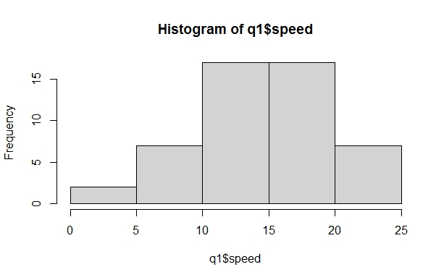

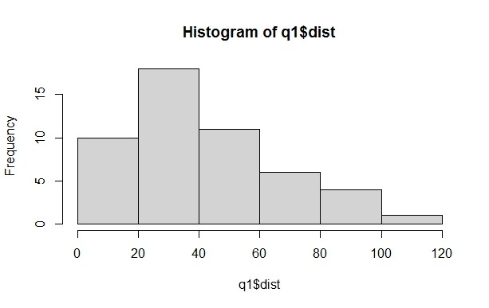

**Inferences of Q9_b file-**

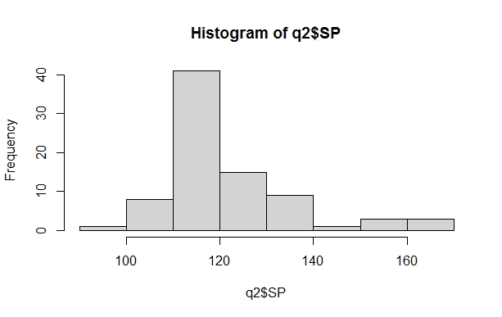

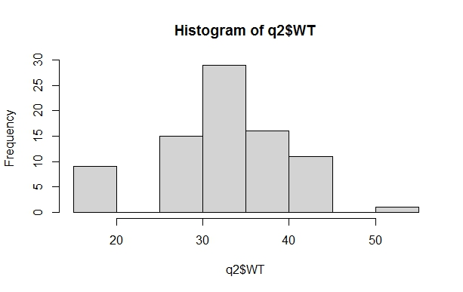

**Q10) Draw inferences about the following boxplot & histogram**



**Ans: -**

The histogram and boxplot in Fig is positively skewed on right side.

i.e mean and median of the data is greater than mode.

**Q11)** Suppose we want to estimate the average weight of an adult male in Mexico. We draw a random sample of 2,000 men from a population of 3,000,000 men and weigh them. We find that the average person in our sample weighs 200 pounds, and the standard deviation of the sample is 30 pounds. Calculate 94%,98%,96% confidence interval?

Ans: -

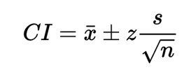 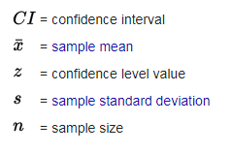

Given : x=200, s=30, n=2000

1. The 94% confidence interval is (198.739,201.62) (z=1.8808)
2. The 96% confidence interval is (198.622,201.378) (z=2.0537)
3. The 98% confidence interval is (198.439,201.561) (z=2.3263)

**Q12)** Below are the scores obtained by a student in tests

**34,36,36,38,38,39,39,40,40,41,41,41,41,42,42,45,49,56**

1. Find mean, median, variance, standard deviation.
2. What can we say about the student marks?

**Ans: -**

1. Mean=41, median=40.5

Variance=25.529

Standard deviation=5.05

1. Repeatably obtained are 36,38,40,41 and 42 Skewness =1.42 i.e., Positive.

Q13) What is the nature of skewness when mean, median of data are equal?

**Ans: -**

If the mean is equal to the median as well as the mode, so the skewness is zero. If the distribution is symmetric, the mean equal to median, and the skewness of the distribution is zero.

Q14) What is the nature of skewness when mean > median?

Ans: -

If the mean is greater than the median, then distribution is positively skewed.

Q15) What is the nature of skewness when median > mean?

Ans: -

If the mean is less than the median, the distribution is negatively skewed.

Q16) What does positive kurtosis value indicates for a data?

Ans: - 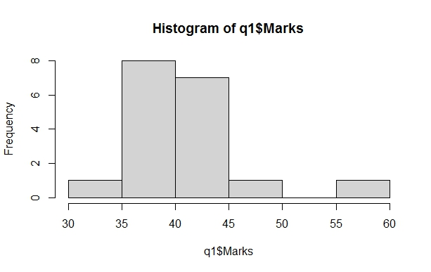

Positive value of kurtosis indicate that distribution is peaked and possesses thick tails. An extreme positive kurtosis indicates a distribution where more of the number are located in the tails of distribution instead of around the mean.

Q17) What does negative kurtosis value indicates for a data?

Ans: -

If a distribution has negative kurtosis, it is said to be platykurtic, which means that it has a flatter peak and thinner tails compared to a normal distribution. this simply means that more data value is located on the tails. Negative kurtosis is the uniform distribution, which has no peak at all and is a completely flat distribution.

Q18) Answer the below questions using the below boxplot visualization.



1.What can we say about the distribution of the data?

2.What is nature of skewness of the data?

3.What will be the IQR of the data (approximately)?

1. Ans: -

The distribution in which more values are concentrated on the right side (tail) of the graph is called Negatively Skewed Distribution, while the left tail of the distribution graph is longer  
  
2.Ans: -

The mean of negative skewed data will be less than the median.

3.Ans: - The IQR describes the middle 50% of value when ordered from lower to highest. The interquartile range (IQR)=Q (3)- Q (1). In above example of data, the IQR = (18-10)

Q19) Comment on the below Boxplot visualizations?



Draw an Inference from the distribution of data for Boxplot 1 with respect Boxplot 2.

Ans: -

In this Fig of boxplot. Boxplot 1 is positively skewed that’s means mean and median is greater than mode. And in boxplot 2 Fig normal distribution that means the skewness for a normal distribution is zero, and any symmetric data should have a skewness near zero.

Q 20) Calculate probability from the given dataset for the below cases

Data _set: Cars.csv

Calculate the probability of MPG of Cars for the below cases.

MPG <- Cars$MPG

* 1. P(MPG>38)
  2. P(MPG<40)

c. P (20<MPG<50)

Ans: - a) 0.3475908

b) 0.7293527

c) 0.01311818

**Explanation-**

a) P(MPG>38) =1-pnorm (38,34.422,9.13144) =0.348

b) P(MPG>40) =1-pnorm (40,34.422,9.13144) =0.7293527

c)P(MPG>50) =1-pnorm (50,34.422,9.13144)-

(1-pnorm (20,34.422,9.13144)) = 0.01311818

Q 21) Check whether the data follows normal distribution

1. Check whether the MPG of Cars follows Normal Distribution

Dataset: Cars.csv

1. Check Whether the Adipose Tissue (AT) and Waist Circumference (Waist) from wc-at data set follows Normal Distribution

Dataset: wc-at.csv

Ans: -

1. The MPG of Cars is highly skewed.

Skewness = -0.1746343

b) 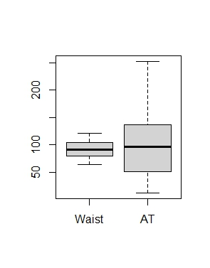**Ans: -**

The waist data set follows normal distribution but AT doesn’t follow normal distribution

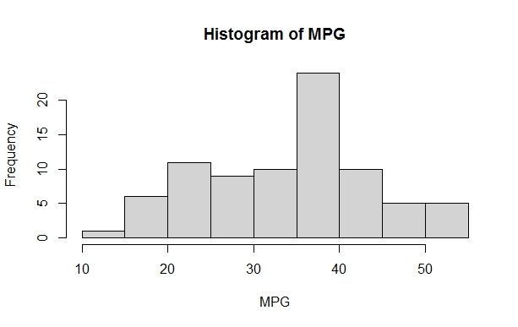

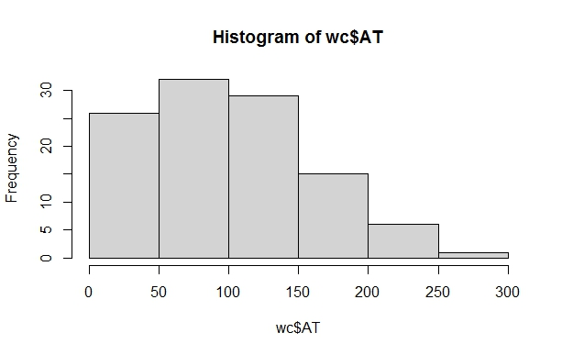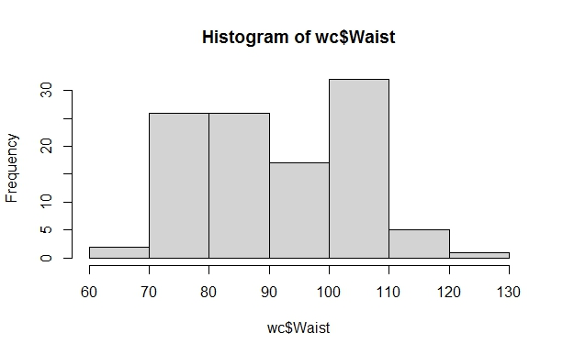

Q 22) Calculate the Z scores of 90% confidence interval,94% confidence interval, 60% confidence interval

Ans: -

Z score of 60% CI = 0.84

Z score of 90% CI = 1.645

Z score of 94% CI = 1.881

Q 23) Calculate the t scores of 95% confidence interval, 96% confidence interval, 99% confidence interval for sample size of 25

Ans: -

|  |  |
| --- | --- |
| **Confidence Interval** | **T Score** |
| 95% | 2.06 |
| 96% | 2.17 |
| 99% | 2.79 |

Q 24**)** A Government company claims that an average light bulb lasts 270 days. A researcher randomly selects 18 bulbs for testing. The sampled bulbs last an average of 260 days, with a standard deviation of 90 days. If the CEO's claim were true, what is the probability that 18 randomly selected bulbs would have an average life of no more than 260 days

Hint:

rcode 🡪 pt(tscore, df)

df 🡪 degrees of freedom

Ans: -

For probability calculations, the number of degrees of freedom is n - 1, so here you need the t-distribution with 17 degrees of freedom.

The probability that **t < - 0.471 with 17 degrees of freedom** assuming the population mean is true, the t-value is less than the t-value obtained with 17 degrees of freedom and a t score of - 0.471, the probability of the bulbs lasting less than 260 days on average of **0.3218** assuming the mean life of the bulbs is 300 days.